**Full Stack Development – Lab 3**

* Component State & Events
* Using Axios with React

**Developer Note:**

* Work can be done in the same create-react-act application. Remember to not include node_modules in the GitHub submission.

**References:**

<http://jsonplaceholder.typicode.com/>

<https://github.com/axios/axios>

**Exercise 1 – Working with Component Data & Axios**

**GET Request**

1. Install Axios using npm install command.



1. Create a file StudentList.js and use the React snippet command cc + tab to create the following Class component.

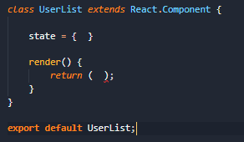

1. Import the the axios library in the ***UserList*** class component.



1. Update the components internal state to store an array of Users.

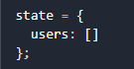

1. Add an internal Component LifeCycle method to make a ***HTTP GET*** request to jsonplaceholder and get a list of User to display after the component has been rendered.
   * Add ***componentDidMount()*** method and make the following call.
   * In the response of the GET request update the users in State using ***this.setState***



1. In the render method of the component, iterate over the list of users in state and output the user names.
2. In the ***App.js***, remove the starter code from ***react-create-app***. Import the ***StudentList*** component and render it with the following expected output.



**POST Request**

1. Create a Component class named ***AddStudent*** and import the Axios library
2. Add a State object that contains the user name we wish to Add

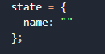

1. Add two events ***handleChange*** and ***handleSubmit***.

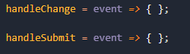

1. Add the following form markup to the Control’s render method.

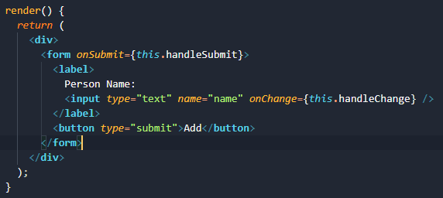

1. Update the ***handleChange*** method to update the user name in the Component state object.
2. Update the ***handleSubmit*** method to send a **POST** request to the url below with the user name to add. The response should be outputted to the console.



Note: in the ***handleSubmit*** we use the ***event.preventDefault*** as the first line in the method, to   
 override the default behavior of the click event.



1. Import the ***AddStudent*** component in the ***App.js*** and render it so that the following is visible in the browser.

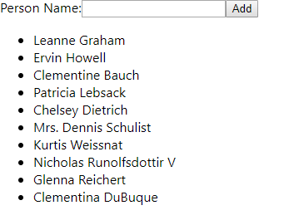

1. The following response should be logged to the console after a ***POST*** call to add the person name.

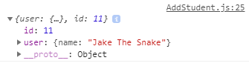

**DELETE Request**

1. Create a Component class named ***DeleteStudent.*** Copy the code from the **AddStudent.js** and modify the ***POST*** request to be a ***DELETE*** request to the following url. The internal state object will track the user Id to delete, not the name. Place this in the App.js render method for testing. ***Output***

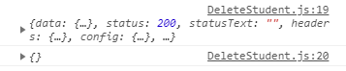

1. Once the ***DeleteStudent*** component is working, add it as a child component in the ***StudentList*** component. It will be passed the user id as it’s props and handle the Delete action by calling the ***DELETE*** Request with the given id.

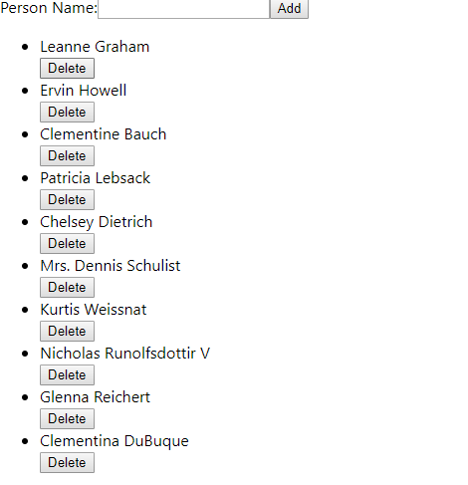

**Homework**

Add the ***AddUser*** component as a nested child component in the ***StudentList*** component. Once a new User has been added trigger a refresh GET Request in the parent ***StudentList***.

Hint: This can be done by passing a event handler reference in the props to the child AddUser component. There will be some extra binding to be done to the function handler to make this work.

**Challenge**

Implement the Delete user to update the list of Students after the student has been deleted from the list.